FAT BEAM LASER BAR

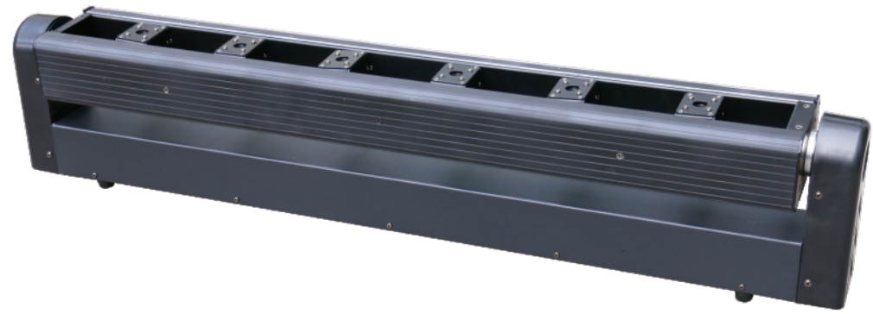

Please read this manual carefully before use!

Contents

Introduction And Caution------------------------------------------------------------P2

Symbol Instruction And Safety Instruction--------------------------------------P3

Installation Instruction----------------------------------------------------------------P4

Product Specification And Manu Operation ------------------------------------P5~P6

DMX Chart ------------------------------------------------------------------------------P7~P10

DMX Connection ----------------------------------------------------------------------P7~P11

Troubleshooting And Fixture Cleaning--------------------------------------------P12

Thank you for your patronage. We are confident that our excellent products and service can satisfy you. For your own safety, please read this user manual carefully before installing the device.

In order to install , operate, and maintain the light correctly, we suggest that the installation and operation should be done by the verified technician with following the instruction strictly.

This moving laser bar’s output is amazing. It is well designed with professional aluminum alloy housing. It makes full use of the advanced electronic positioning technology, and with international standard DMX512 control system. It is ideal for TV show, disco, dancing hall, night club, stage...and some applications outdoor.

Parts inside the box:
Item | Quantity | Unit
Light fixture | 1 | pc
User Manuel | 1 | pc
Power Cable | 1 | pc
Safety Rope | 1 | pc
Handle | 2 | pcs

Please check carefully that there is no damage caused by transportation. Please contact your local dealer if any problem.
Caution
Before leaving the factory, this unit has passed strict inspection, functions stable and perfect packing. If this unit is operated in any way different to the one described in this manual, the product may suffer damages and the guarantee becomes void. Furthermore, any other operation may lead to dangers like short circuit, burns, electric shock, crash etc. If any technology changes of this manual, company do not notice in further and have interpretation.


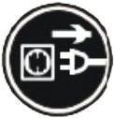
CAUTION!

Keep this device away from rain and moisture!

Unplug mains lead before opening the housing!


Warning!

Damages caused by the disregard of this user manual are not subject to warranty. The dealer will not accept liability for any resulting defects or problems.

Symbol Instruction On The Device
……………………………………………………………

…

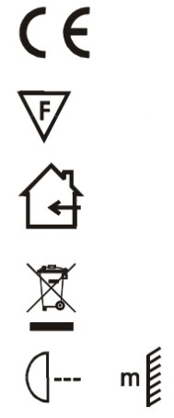
CE Certificate
………

…

……………………………………………………

…

……………………………………………

…

…………………

…

Suitable directly installed on the common combustible materials devices
Only indoor using
Environmental protection
The minimum distance from lighted objects(meter)
Safety Instructions

This unit was in perfect condition before leaving factory. In order to maintain this condition and to ensure a safe operation, it is absolutely necessary for the user to follow the safety instructions and warning notes written in this user manual.

►Unpack and check carefully there is no transportation damage before using the unit.

►Disconnect main power before replacement or servicing.

►The unit must be installed in a location with adequate ventilation, at least 50cm from adjacent
surfaces. Be sure that no ventilation slots are blocked.

►Maximum ambient temperature is Ta: 40 degrees C. DO NOT operate it where the temperature is
higher than this.

►In the event of a serious operating problem, stop using the unit immediately. Never try to repair the
unit by yourself. Repairs carried out by unskilled people can lead to damage or malfunction. Please
contact the nearest authorized technical assistance center. Always use the same type spare parts.

►DO NOT connect any dimmer.

►DO NOT touch any cables during operation as high voltage may cause electric shock.

►To prevent or reduce the risk of electrical shock or fire, do not expose the unit to rain or moisture.

►After unit working for 8 hours continuously, let the unit to take appropriate rest. It can reduce some damage and good for lifetime.

►Laser radiation avoids body exposure, especially for eye, it’s easy to cause blindness. Please keep the
safe distance at 1 meters above.

►To prevent or reduce the risk of electrical shock or fire, do not expose the unit to rain or moisture.

►The housing and lenses must be replaced if they are visibly damaged.

CAUTION!
 Please consider the GB7000.15/EN60598-2-17 and the other respective national norms during
The installation. The installation must only be carried out by a qualified person.

Installation Instruction

- This unit can not be installed on the surface of flammable materials. Please ensure the unit is at least 0.5m away from flammable and explosive materials.

- The installation must always be secured with a secondary safety e.g. an appropriate safety rope.Never stand directly below the device when mounting, removing or servicing the fixture.

- The applicable temperature for the lighting is between -10°C to 45°C. Do not use the lighting under or above the temperature.

- Before installation, must ensure installation bracket, handle or truss for this light can hold 10 times of the fixture weight for 1 hour without any harming deformation.

- The operator has to make sure the safety relating and machine technical installations are approved by an expert before taking the device into operation for the first time.

- These installations have to be approved by a skilled person once a year.

- Overhead mounting requires extensive experience, including others calculating working load limits, installation material being used, and periodic safety inspection of all installation material and the device. If you lack these qualifications, do not attempt the installation yourself. Improper installation can result in bodily injury.

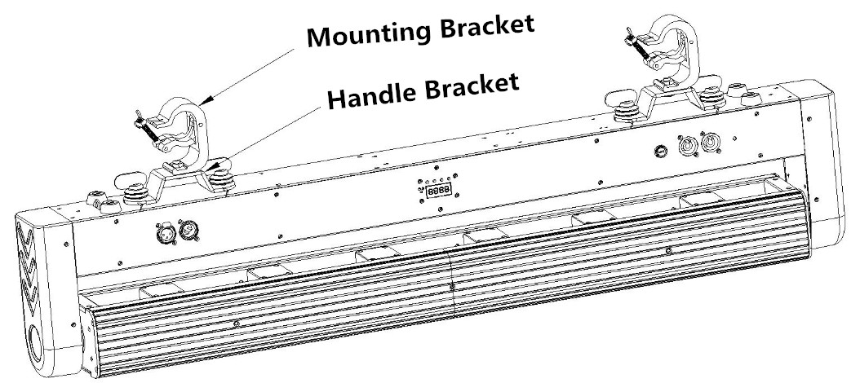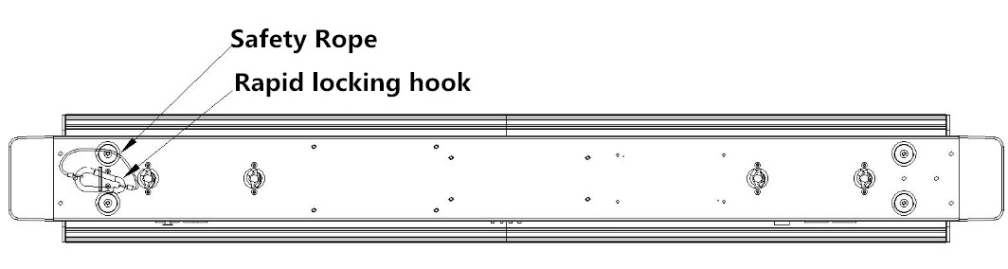

Insert the quick-lock fasteners of the first holder into the respective holes on the bottom of the device.Tighten the quick-lock fasteners fully clockwise.
Make the finished installed mounting bracket tighten on the fixed bracket.
Pull the safety rope through the holes on the bottom of the base and over the trussing system or other safe fixation spot.
Note:This step is quite important to ensure that fixture will not drop out by the damage of clamp.

Product specification
Red laser diode: 500mw/638nm, average lifetime is over 2000 hours, low power consumption.
DMX channel：9CH/19-1CH/19-2CH
Control mode ：Master/Slave, Auto, DMX512, Sound
Pan: 240º, Tilt: 90º
Electrical strobe: 1~23Hz；
Input voltage：AC100 ~240V 50/60Hz，
Power consumption: 90W
3pin DMX input/output, Power Con input/output

Display
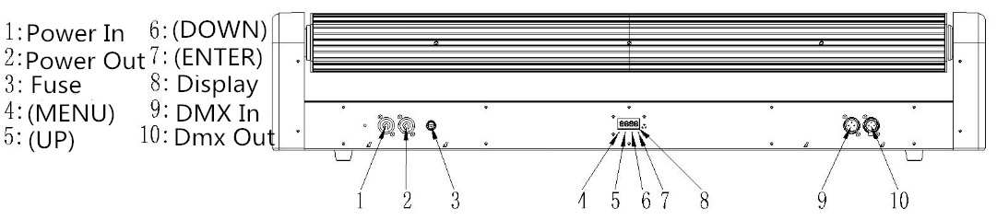

MENU Nap
Nenu （MENU） | Addr (Address setting) | enter | +/- | set address（001-512） | enter(save and exit)
Nenu （MENU） | Chnd  (Channel option) | enter | +/- | 9 Ch | enter(save and exit)
 |  |  |  | 19_1Ch | enter(save and exit)
 |  |  |  | 19_2Ch | enter(save and exit)
Nenu （MENU） | SLnd (Master/Slave) | enter | +/- | Mast | enter(save and exit)
 |  |  |  | SL 1 | enter(save and exit)
Nenu （MENU） | Lost (Without DMX) | enter | +/- | blac (Master) | enter(save and exit)
 |  |  |  | hold | enter(save and exit)
 |  |  |  | auto (Auto) | enter(save and exit)
 |  |  |  | soun (Sound) | enter(save and exit)
Nenu （MENU） | Sens (Sound sensitivity) | enter | +/- | SE00-SE99 | enter(save and exit) ）
Nenu （MENU） | Sped (Auto Speed) | enter | +/- | SP00-SP99 | enter(save and exit)
Nenu （MENU） | Inur (Reverse setting) | enter | +/- | Pan --> YES/NO | enter(save and exit)
 |  |  |  | Til1 --> YES/NO | enter(save and exit)
 |  |  |  | Til2 --> YES/NO | enter(save and exit)
 |  |  |  | Til3 --> YES/NO | enter(save and exit)
 |  |  |  | Til4 --> YES/NO | enter(save and exit)
 |  |  |  | Til5 --> YES/NO | enter(save and exit) ）
 |  |  |  | Til6 --> YES/NO | enter(save and exit)
Nenu （MENU） | Nadj (Motor adjustment) | enter | +/- | Padj --> 000-255 | enter(save and exit)
 |  |  |  | T1aj --> 000-255 | enter(save and exit)
 |  |  |  | T2aj --> 000-255 | enter(save and exit)
 |  |  |  | T3aj --> 000-255 | enter(save and exit)）
 |  |  |  | T4aj --> 000-255 | enter(save and exit)
 |  |  |  | T5aj --> 000-255 | enter(save and exit)
 |  |  |  | T6aj --> 000-255 | enter(save and exit)
Nenu （MENU） | Test (Programme test) | enter | +/- | Function test | enter(save and exit)
Nenu （MENU） | Led (Black-out) | enter | +/- | on | enter(save and exit)
 |  |  |  | off | enter(save and exit)
Nenu （MENU） | disp (Display reverse) | enter | +/- | on | enter(save and exit)
 |  |  |  | off | enter(save and exit)
Nenu （MENU） | Fhrs  (Working time) | enter |  | Working time | enter(save and exit)
Nenu （MENU） | Ver  (Software version) | enter |  | Software version | enter(save and exit)
Nenu （MENU） | REST | enter |  | Rest function | enter(save and exit)
Nenu （MENU） | defa  (Factory default) | enter |  | Factory default | enter(save and exit)

MENU operation

This fixture has 4 keys on panel for operation, press these keys to set DMX address, reset, edit and run programs and so on.

[MENU]: press MENU key to enter edit status, in edit status, if press MENU again, it will return the upper interface. If no operation 30 seconds after enter edit status, the fixture will exit the edit status automatically.

[Up]: press UP key, the indicator will flash, the address increases one by one, if hold the key continuously, the address will increase rapidly. If no press within 30 seconds, the indicator stops flashing and exit it. In edit status, press UP key, it will display the options circularly from down to up.

[Down]：press DOWN key, the indicator will flash, the address decreases one by one, if hold the key continuously, the address will decrease rapidly. If no press within 30 seconds, the indicator stops flashing and exit it. In edit status, press DOWN key, it will display the options circularly from up to down.

[ENTER]：in normal status, no function after press ENTER. In edit mode, press ENTER to enter lower interface.

DMX512 Channel

- 9 DMX Channel chart

Channel |  | Value | Function
CH1 | Pan | 000-255 | Pan angle：0-260°
CH2 | Pan Speed | 000-255 | Pan speed from slow to fast
CH3 | Tilt | 000-255 | Tilt 1-6；Pan：0-90°
CH4 | Tilt Speed | 000-255 | Tilt speed from slow to fast
CH5 | Dimmer | 000-127 | OFF
CH5 | Dimmer | 128-255 | ON
CH6 | Strobe | 000-015 | OFF
CH6 | Strobe | 016-030 | ON
CH6 | Strobe | 031-090 | Variable strobe from slow to fast
CH6 | Strobe | 091-105 | ON
CH6 | Strobe | 106-165 | Pulse effect from slow to fast
CH6 | Strobe | 166-180 | ON
CH6 | Strobe | 181-240 | Random strobe from slow to fast
CH6 | Strobe | 241-255 | ON
CH7 | Laser 1-6 | 000-127 | OFF
CH7 | Laser 1-6 | 128-255 | ON
CH8 | Reset / Auto | 000-010 | NO FUNCTION
CH8 | Reset / Auto | 011-026 | SHOW 1
CH8 | Reset / Auto | 027-032 | SHOW 2
CH8 | Reset / Auto | 033-048 | SHOW 3
CH8 | Reset / Auto | 049-064 | SHOW 4
CH8 | Reset / Auto | 065-080 | SHOW 5
CH8 | Reset / Auto | 081-096 | SHOW 6
CH8 | Reset / Auto | 097-112 | SHOW 7
CH8 | Reset / Auto | 113-128 | SHOW 8
CH8 | Reset / Auto | 129-1144 | SHOW 9
CH8 | Reset / Auto | 145-160 | SHOW 10
CH8 | Reset / Auto | 161-176 | SHOW 11
CH8 | Reset / Auto | 177-192 | SHOW 12
CH8 | Reset / Auto | 193-208 | SHOW 13
CH8 | Reset / Auto | 209-224 | SHOW 14
CH8 | Reset / Auto | 225-240 | Auto effect
CH8 | Reset / Auto | 241-250 | Auto effect
CH8 | Reset / Auto | 251-255 | Reset
CH9 | Auto program / Sound mode | 000-250 | Program speed from slow to fast
CH9 | Auto program / Sound mode | 251-255 | Sound mode

- 19-1 DMX Channel chart

Channel |  | Value | Function
CH1 | Pan | 000-255 | Pan angle：0-260°
CH2 | Pan Speed | 000-255 | Pan speed from fast to slow
CH3 | Tilt1 | 000-255 | Tilt angle：0-90°
CH4 | Tilt2 | 000-255 | Tilt angle：0-90°
CH5 | Tilt3 | 000-255 | Tilt angle：0-90°
CH6 | Tilt4 | 000-255 | Tilt angle：0-90°
CH7 | Tilt5 | 000-015 | Tilt angle：0-90°
CH8 | Tilt6 | 000-255 | Tilt angle：0-90°
CH9 | Tilt Speed | 000-255 | Pan speed from fast to slow
CH10 | Dimmer | 000-127 | OFF
CH10 | Dimmer | 128-255 | ON
CH11 | Strobe | 000-015 | OFF
CH11 | Strobe | 016-030 | ON
CH11 | Strobe | 031-090 | Variable strobe from slow to fast
CH11 | Strobe | 091-105 | ON
CH11 | Strobe | 106-165 | Pulse effect from slow to fast
CH11 | Strobe | 166-180 | ON
CH11 | Strobe | 181-240 | Random strobe slow from slow to fast
CH11 | Strobe | 241-255 | ON
CH12 | Laser1 | 000-127 | OFF
CH12 | Laser1 | 128-255 | ON
CH13 | Laser2 | 000-127 | OFF
CH13 | Laser2 | 128-255 | ON
CH14 | Laser3 | 000-127 | OFF
CH14 | Laser3 | 128-255 | ON
CH15 | Laser4 | 000-127 | OFF
CH15 | Laser4 | 128-255 | ON
CH16 | Laser5 | 000-127 | OFF
CH16 | Laser5 | 128-255 | ON
CH17 | Laser6 | 000-127 | OFF
CH17 | Laser6 | 128-255 | ON
CH18 | Reset / Auto | 000-010 | NO FUNCTION
CH18 | Reset / Auto | 011-026 | SHOW1
CH18 | Reset / Auto | 027-032 | SHOW2
CH18 | Reset / Auto | 033-048 | SHOW3
CH18 | Reset / Auto | 049-064 | SHOW4
CH18 | Reset / Auto | 065-080 | SHOW5
CH18 | Reset / Auto | 081-096 | SHOW6
CH18 | Reset / Auto | 097-112 | SHOW7
CH18 | Reset / Auto | 113-128 | SHOW8
CH18 | Reset / Auto | 129-1144 | SHOW9
CH18 | Reset / Auto | 145-160 | SHOW10
CH18 | Reset / Auto | 161-176 | SHOW11
CH18 | Reset / Auto | 177-192 | SHOW12
CH18 | Reset / Auto | 193-208 | SHOW13
CH18 | Reset / Auto | 209-224 | SHOW14
CH18 | Reset / Auto | 225-240 | Auto effect
CH18 | Reset / Auto | 241-250 | Auto effect
CH18 | Reset / Auto | 251-255 | Reset
CH19 | Auto program speed / Sound mode | 000-250 | Program from speed slow to fast
CH19 | Auto program speed / Sound mode | 251-255 | Sound mode

- 19-2 DMX Channel chart
Channel |  | Value | Function
CH1 | Tilt 1 | 000-255 | Tilt angle：0-90°
CH2 | Laser 1 | 000-127 | OFF
CH2 | Laser 1 | 128-255 | ON
CH3 | Tilt 2 | 000-255 | Tilt angle：0-90°
CH4 | Laser2 | 000-127 | OFF
CH4 | Laser2 | 128-255 | ON
CH5 | Tilt 3 | 000-255 | Tilt angle：0-90°
CH6 | Laser 3 | 000-127 | OFF
CH6 | Laser 3 | 128-255 | ON
CH7 | Tilt 4 | 000-255 | Tilt angle：0-90°
CH8 | Laser 4 | 000-127 | OFF
CH8 | Laser 4 | 128-255 | ON
CH9 | Tilt 5 | 000-015 | Tilt angle：0-90°
CH10 | Laser 5 | 000-127 | OFF
CH10 | Laser 5 | 128-255 | ON
CH11 | Tilt 6 | 000-255 | Tilt angle：0-90°
CH12 | Laser 6 | 000-127 | OFF
CH12 | Laser 6 | 128-255 | ON
CH13 | Dimmer | 000-127 | OFF
CH13 | Dimmer | 128-255 | ON
CH14 | Strobe | 000-015 | OFF
CH14 | Strobe | 016-030 | ON
CH14 | Strobe | 031-090 | Variable strobe from slow to fast
CH14 | Strobe | 091-105 | ON
CH14 | Strobe | 106-165 | Pulse effect from slow to fast
CH14 | Strobe | 166-180 | ON
CH14 | Strobe | 181-240 | Random strobe from slow to fast
CH14 | Strobe | 241-255 | ON
CH15 | Pan | 000-255 | Pan angle：0-260°
CH16 | Pan Speed | 000-255 | Pan speed from fast to slow
CH17 | Tilt Speed | 000-255 | Pan speed from fast to slow
CH18 | Reset / Auto | 000-010 | NO FUNCTION
CH18 | Reset / Auto | 011-026 | SHOW 1
CH18 | Reset / Auto | 027-032 | SHOW 2
CH18 | Reset / Auto | 033-048 | SHOW 3
CH18 | Reset / Auto | 049-064 | SHOW 4
CH18 | Reset / Auto | 065-080 | SHOW 5
CH18 | Reset / Auto | 081-096 | SHOW 6
CH18 | Reset / Auto | 097-112 | SHOW 7
CH18 | Reset / Auto | 113-128 | SHOW 8
CH18 | Reset / Auto | 129-1144 | SHOW 9
CH18 | Reset / Auto | 145-160 | SHOW 10
CH18 | Reset / Auto | 161-176 | SHOW 11
CH18 | Reset / Auto | 177-192 | SHOW 12
CH18 | Reset / Auto | 193-208 | SHOW 13
CH18 | Reset / Auto | 209-224 | SHOW 14
CH18 | Reset / Auto | 225-240 | Auto effect
CH18 | Reset / Auto | 241-250 | Auto effect
CH18 | Reset / Auto | 251-255 | Reset
CH19 | Auto program speed / Sound mode | 000-250 | Program speed from slow to fast
CH19 | Auto program speed / Sound mode | 251-255 | Sound mode

DMX-512 connection
Connect the provided XLR cable to the male 3-pin XLR output of your controller and the other side to the female 3-pin XLR input of the light.You can chain multiple lights together through serial linking

The cable needed should be two core, screened cable with XLR input and output connectors. Please refer to the diagram below.
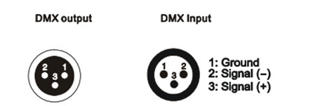
XLR Mounting socket
XLR Mounting plug

DMX address setting
Each fixture must have a specific starting address. When receiving signal transmission, fixture will receive channel control signals from DMX controller through this starting address.
According to different requirements or easy to use, the user can set many fixtures to the same address, also can set up a separately address for every device.
If more than one fixtures have the same address, all of them receive the same DMX channel signal from DMX controller. All connected fixtures are jointly controlled, DMX controller can't control a device separately.
If each device has a different address, each device will be separate and accept separate DMX512 control signal through the separate DMX address, so that more convenient to control one device separately. this method must be based on channel quantity of device to determine a starting address.
This device has 55 channels, so the first device starting address set 1, second is 56(1+55), third is 111(56+55) and so on.

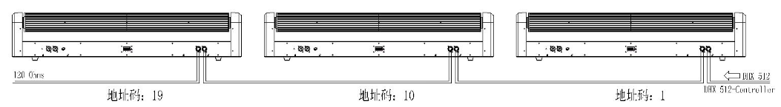

Troubleshooting
Following are a few common problems that may occur during operation. Here are some suggestions for easy troubleshooting:

- The fixture does not work, no light
1. Check the connection of power and main fuse.
2. Measure the mains voltage on the main connector.

B. Not responding to DMX controller
1. DMX LED should be on. If not, check DMX connectors, cables to see if link properly.
2. If the DMX LED is on and no response to the channel, check the address settings and DMX polarity.
3. If you have intermittent DMX signal problems, check the pins on connectors or on PCB of the fixture or the previous one.
4. Try to use another DMX controller.
5. Check if the DMX cables run near or run alongside to high voltage cables that may cause damage or interference to DMX interface circuit.

Fixture Cleaning

The cleaning of internal must be carried out periodically to optimize light output. Cleaning frequency depends on the environment in which the fixture operates: damp, smoky or particularly dirty surrounding can cause greater accumulation of dirt on the fixture’s optics.
- Clean with soft cloth using normal glass cleaning fluid.
- Always dry the parts carefully.
- Clean the external optics at least every 15 days. Clean the internal optics at least every 30/60 days.

